A Mini Project Report on

**Image Steganography**

Submitted in partial fulfillment of the requirements for the

award of the degree of

**Bachelor of Engineering**

In

**Computer Engineering**

By

**Ashish Yadav**

**Srishti Shrivastava**

**Gauri Vispute**

**Vivek Tiwari**

Under the Guidance of

**Prof. Nilesh Mehta**



**Department of Computer Engineering**

**Watumull Institute of Electronics Engineering and Computer Technology**

**Ulhasnagar**

UNIVERSITY OF MUMBAI

**Academic Year 2022-2023**

**Approval Sheet**

This Mini Project Report entitled “***Image Steganography***” Submitted by ***"Ashish Yadav",*** ***"Srishti Shrivastava",*** ***"Gauri Vispute",*** ***"Vivek Tiwari",*** is approved for the partial fulfillment of the requirement for the award of the degree of Bachelor of Engineering in ***Computer Science*** from University of Mumbai.

(Prof. Nilesh Mehta)

Guide

Head Department of Computer Engineering

Place: Ulhasnagar

Date: 25th April, 2023

**CERTIFICATE**

This is to certify that the mini project entitled “***Image Steganography***” Submitted by ***"Ashish Yadav",*** ***"Srishti Shrivastava",*** ***"Gauri Vispute",*** ***"Vivek Tiwari",***  for the partial fulfillment of the requirement for award of a degree Bachelor of Engineering in Computer Engineering, to the University of Mumbai, is a bonafide work carried out during academic year 2022-2023.

Guide Name & Signature Examiners:

1.

2.

Head Department of Computer Engineering Principal

Place: Ulhasnagar

Date: 25th April, 2023

**Declaration**

We declare that this written submission represents our ideas in our own words and where others’ ideas or words have been included, we have adequately cited and referenced the original sources. We also declare that we have adhered to all principles of academic honesty and integrity and have not misrepresented or fabricated or falsified any idea/data/fact/source in our submission. We understand that any violation of the above will be cause for disciplinary action by the Institute and can also evoke penal action from the sources which have thus not been properly cited or from whom proper permission has not been taken when needed.

———————————————

(Signature)

———————————————

Ashish Yadav

Srishti Shrivastava

Gauri Vispute

Vivek Tiwari

Date: 25th April, 2023

**Abstract**

This project of Image steganography is a technique of hiding secret information within an image without altering its perceptual quality. In this mini project, we propose an implementation of image steganography using a combination of least significant bit (LSB) substitution and encryption. The secret message is first encrypted using the Advanced Encryption Standard (AES) algorithm to ensure confidentiality. The encrypted message is then embedded into the LSBs of the cover image.

The resulting stego-image appears identical to the original cover image and can be sent through any communication channel without arousing suspicion. The proposed implementation is evaluated using various metrics, including peak signal-to-noise ratio (PSNR) and structural similarity index (SSIM), to measure the quality of the stego-image. The experimental results demonstrate the effectiveness of the proposed method in achieving high security and good visual quality of the stego-image.

**Contents**

1. **Introduction 7**
2. Problem Definition
3. Objectives
4. **Theory 8**
   1. Methods
5. **Technology Stack 11** 
   1. Code Editor
   2. Languages
6. **Benefits and Applications 15**
7. **Project Design 16**
8. Proposed System
9. Flow of Modules
10. **Project Access 22**
11. **Result 23**
12. **Bibliography 24**

**1.Introduction**

1.1 Problem Definition

The problem that it aims to address is the need for secure communication of sensitive information over insecure channels. Traditional encryption techniques, such as AES, can provide confidentiality, but they do not hide the fact that a message is being sent. Steganography addresses this issue by hiding the secret message within an innocent-looking cover image. The challenge lies in embedding the message in a way that is imperceptible to the human eye and difficult to detect by automated analysis. This project aims to develop an image steganography method that can achieve high security while maintaining the quality of the cover image.

1.2 Objectives

The objective of the image steganography mini project is to design and implement a secure and efficient method for hiding secret information within an image without altering its visual appearance. There are specific objectives such as implementing the least significant bit (LSB) substitution technique for embedding the secret message into the cover image.Comparing the proposed method with existing image steganography techniques to demonstrate its effectiveness in terms of security and visual quality.

Providing a user-friendly interface to enable easy usage of the developed image steganography tool.

Overall, the objective is to develop a robust image steganography method that can be used for secure communication of sensitive information over insecure channels.

**2.Theory**

For experts, secretive data transmission, and privacy of users, the basic methods are: Steganography and Cryptography.

Steganography is a simple security method. Generally there are three different methods used for hiding information: steganography, cryptography, watermarking.

In cryptography, the information to be hidden is encoded using certain techniques; this information is generally understood to be coded as the data appears nonsensical. Steganography is hiding information; this generally cannot be identified because the coded information doesn’t appear to be abnormal i.e. its presence is undetectable by sight.

Detection of steganography is called Steganalysis. Steganography is of different types: 1. Text steganography 2. Image steganography 3. Audio steganography 4. Video steganography.

In all of these methods, the basic principle of steganography is that a secret message is to be embedded in another cover object which may not be of any significance in such a way that the encrypted data would finally display only the cover data. So it cannot be detected easily to be containing hidden information unless proper decryption is used.

As the above explanation goes, every steganography consists of three components: 1. Cover object 2. Message object 3. Resulting Steganographic object

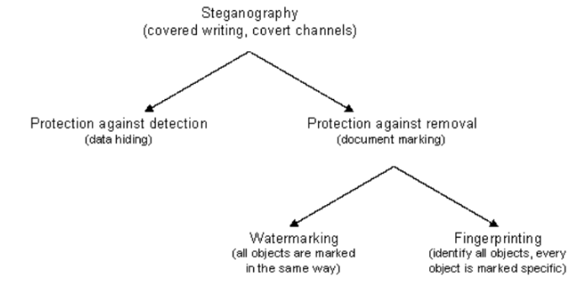

2.1 Methods

There are two different methods for image steganography:

1. Spatial methods 2. Transform methods

We are more concerned with Spatial methods here -

**Spatial methods**

Spatial methods in image steganography involve manipulating the spatial domain of an image to embed a secret message. There are various techniques used in spatial domain steganography, including:

Least Significant Bit (LSB) Substitution: This is the most commonly used technique in spatial domain steganography. LSB substitution involves replacing the least significant bits of the pixel values in the cover image with the bits of the secret message. This technique is widely used because it is simple, fast, and easy to implement. However, it can be vulnerable to statistical analysis attacks.

Pixel-Value Differencing (PVD): PVD is a more secure spatial domain steganography technique that involves modifying the difference between the adjacent pixel values in an image to embed the secret message. This technique ensures that the statistical properties of the cover image are preserved, making it difficult to detect the presence of the hidden message.

Spread Spectrum (SS): SS is a more complex spatial domain steganography technique that involves adding a pseudo-random noise pattern to the cover image to hide the secret message. This technique ensures that the hidden message is spread out over a wide range of frequencies, making it difficult to detect. However, this technique requires more computational resources compared to other techniques.

Though we have used **LSB** method in our project

Overall, spatial domain steganography techniques are widely used due to their simplicity and ease of implementation. However, they can be vulnerable to statistical analysis attacks, and their capacity for embedding secret messages is limited by the size of the cover image.

**3.Technology Stack**

3.1 Code Editor

**Microsoft Visual Studio Code**

Visual Studio Code is a source-code editor made by Microsoft for Windows, Linux and macOS. Features include support for debugging, syntax highlighting, intelligent code completion, snippets, code refactoring, and embedded Git. Users can change the theme, keyboard shortcuts, preferences, and install extensions that add additional functionality.

**Language support**

Out of the box, Visual Studio Code includes basic support for most common programming languages. This basic support includes syntax highlighting, bracket matching, code folding, and configurable snippets. Visual Studio Code also ships with IntelliSense for JavaScript, TypeScript, JSON, CSS, and HTML, as well as debugging support for Node.js. Support for additional languages can be provided by freely available extensions on the VS Code Marketplace.

**Version control**

Source control is a built-in feature of Visual Studio Code. It has a dedicated tab inside of the menu bar where you can access version control settings and view changes made to the current project. To use the feature, you must link Visual Studio Code to any supported version control system (Git, Apache Subversion, Perforce, etc.). This allows you to create repositories as well as make push and pull requests directly from the Visual Studio Code program.

3.2 Languages

**Programming language - Python**

Python is a high-level programming language that is widely used for various purposes such as data analysis, web development, scientific computing, and artificial intelligence. Python provides a simple and easy-to-learn syntax, making it an excellent choice for beginners and experts alike. Python is Open Source which means its available free of cost. It is simple and so easy to learn. It is versatile and can be used to create many different things. It has powerful development libraries include AI, ML etc.

**Image Processing library – Pillow**

Pillow is a popular Python library used for image processing and manipulation. It is a fork of the Python Imaging Library (PIL) and is compatible with Python 3.x. Pillow provides a variety of image processing capabilities such as reading and writing images in various formats, resizing, cropping, rotating, and filtering images. Some of the key features of Pillow:

Image opening and saving: Pillow can open and save images in various formats such as JPEG, PNG, BMP, GIF, TIFF, and WebP.

Image resizing and cropping: Pillow can resize and crop images to various sizes and aspect ratios.

Image filtering and enhancement: Pillow provides various filters and enhancement methods to improve the quality of images, such as blurring, sharpening, and color correction.

Image manipulation: Pillow can rotate, flip, and transpose images.

Image drawing: Pillow provides various methods for drawing on images, such as drawing lines, rectangles, and circles.

Image metadata: Pillow can read and modify the metadata of images, such as the image size, resolution, and color space.

**GUI Development – Tkinter**

Python provides the standard library Tkinter for creating the graphical user interface for desktop based applications. Developing desktop based applications with python Tkinter is not a complex task. It is a standard Python library used for creating graphical user interfaces (GUIs) in Python. It is based on the Tk GUI toolkit and provides a simple and easy-to-use interface for creating GUI applications. It is available in all standard Python distributions, making it easy to use and accessible to beginners.

Tkinter is a Python GUI (Graphical User Interface) toolkit that is built on top of the Tcl/Tk GUI toolkit. It provides a set of tools and widgets for creating graphical applications in Python.

With Tkinter, you can create windows, dialogs, buttons, menus, text boxes, and other GUI elements, and then add functionality to them using Python code. It also provides a powerful event handling mechanism, which allows you to respond to user actions such as button clicks, mouse movements, and keyboard input.

**Development & Version Control tools – Git & GitHub**

**Git :**

Git is a distributed version control system that allows you to track changes to files and collaborate with others on software development projects. Git works by storing a complete history of all changes made to a project's files in a repository. Each time you make changes to a file, you can create a new version of the file and add it to the repository. Git tracks the differences between each version of the file, allowing you to easily view, compare, and revert changes.

Git also allows you to collaborate with others on a project by allowing multiple developers to work on the same files simultaneously. Each developer can make changes to their own local copy of the repository and then push their changes to a central repository hosted on a server, where they can be merged with the changes made by other developers.

**GitHub :**

GitHub is a web-based platform that provides hosting for Git repositories, as well as a wide range of tools and features for collaborating on software development projects. GitHub allows developers to host their Git repositories online and easily collaborate with others on their code.

GitHub also provides integration with many other tools and services commonly used in software development, such as continuous integration and deployment tools, code quality analysis tools, and project management tools.

GitHub is used by millions of developers and companies worldwide, and is an important tool for open-source projects, as well as for commercial software development. It is often used as a platform for collaboration and communication between developers, and for showcasing and sharing code with the wider community.

**4.Benefits and Applications**

1. Security: Image steganography provides a high level of security for data transmission, as the secret information is hidden inside the image, making it difficult for an attacker to detect and retrieve the information.
2. Confidentiality: Image steganography can be used to maintain confidentiality of sensitive information such as passwords, credit card numbers, and personal identification information.
3. Authentication: Image steganography can be used as a method of authentication, by embedding a secret code or message within an image to verify the authenticity of the message or sender.
4. Watermarking: Image steganography can be used to embed watermarks into digital images, to identify the owner of the image or to prevent unauthorized use of the image.
5. Copyright protection: Image steganography can be used to protect copyrighted material such as images, videos, and music by embedding information that identifies the owner of the material.
6. Covert communication: Image steganography can be used as a method of covert communication, where messages can be hidden inside an innocent-looking image and sent without arousing suspicion.
7. Military and intelligence: Image steganography can be used for military and intelligence applications, where secret messages can be embedded in images and sent to troops or agents in the field.

**5. Project Design**

5.1 Proposed System

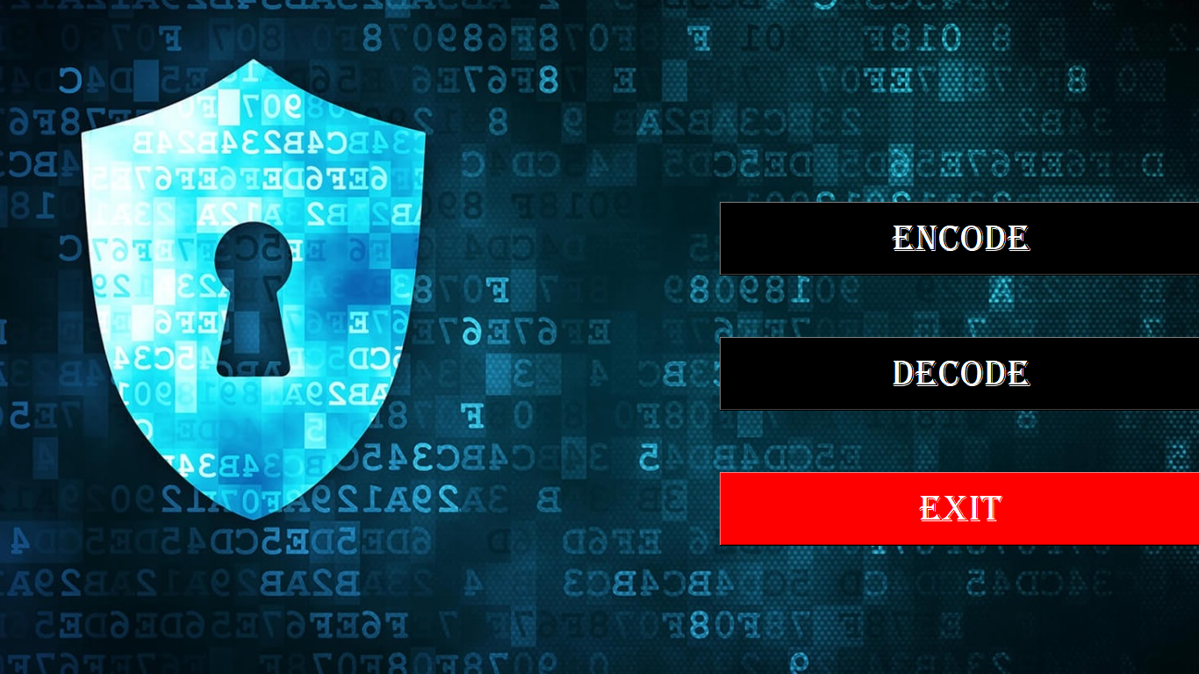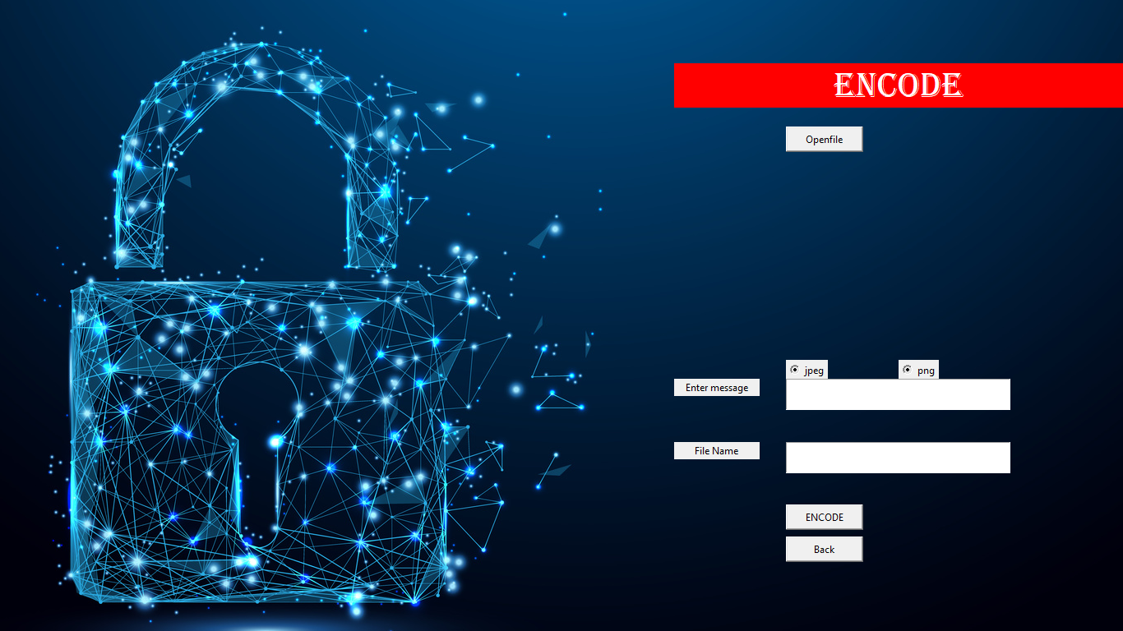

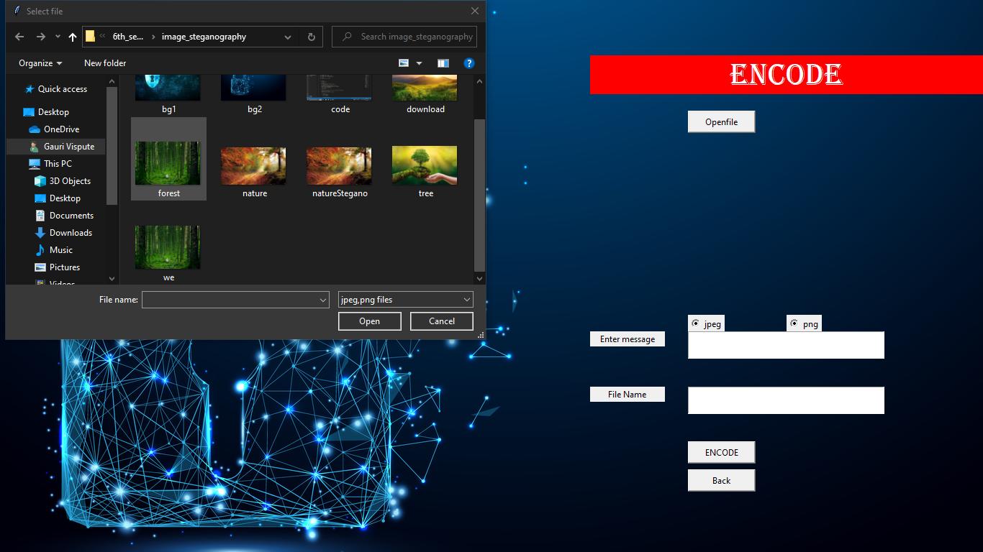

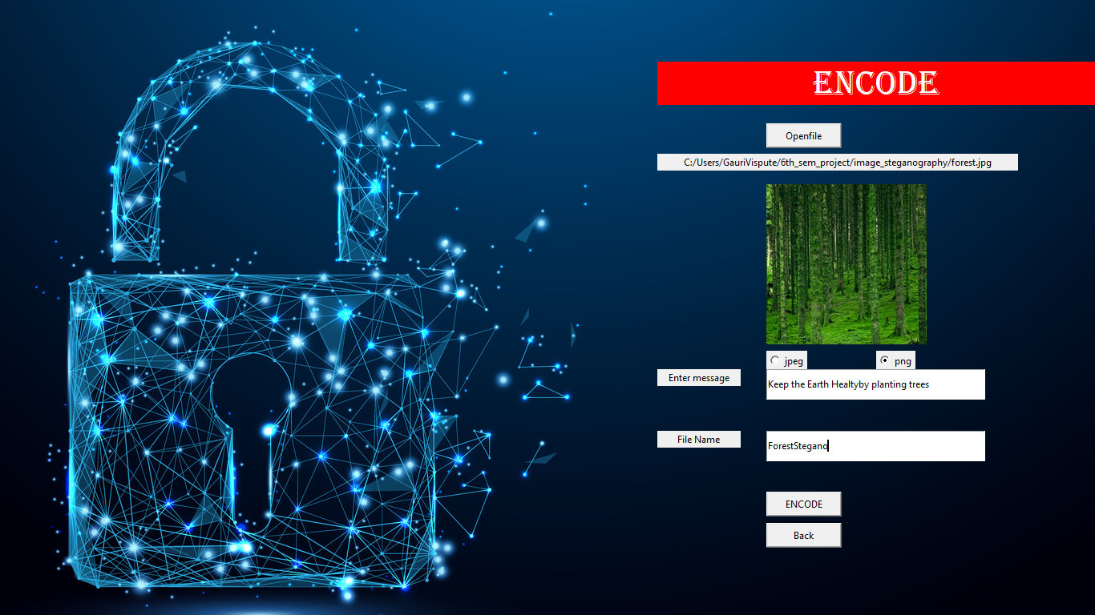

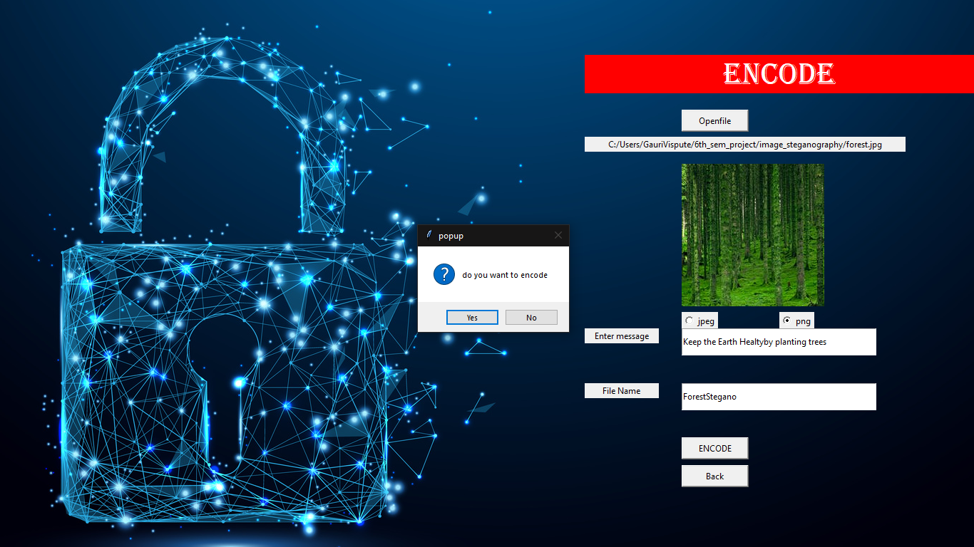

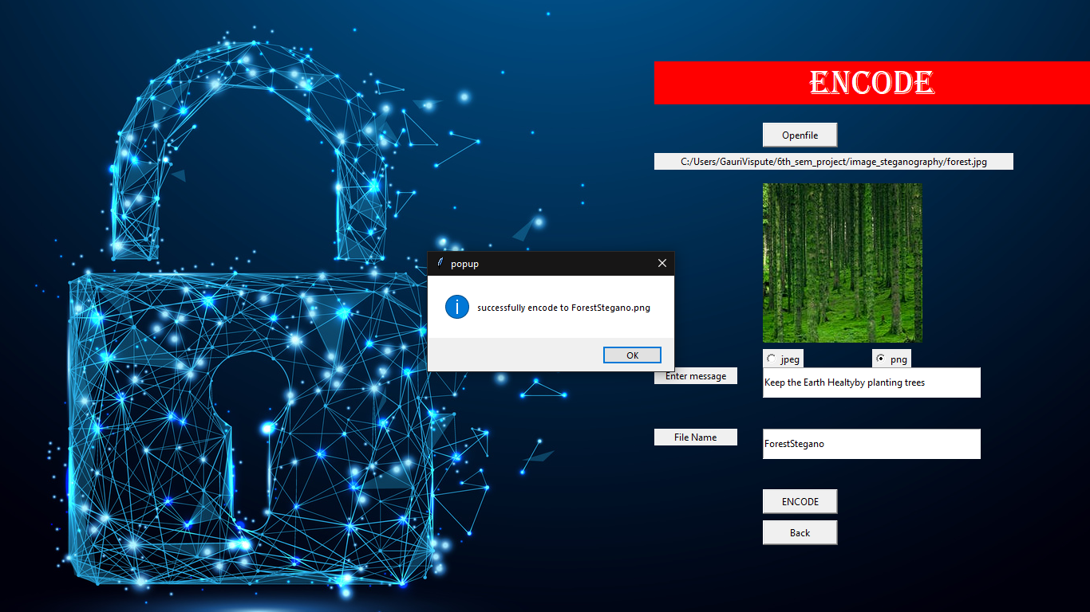

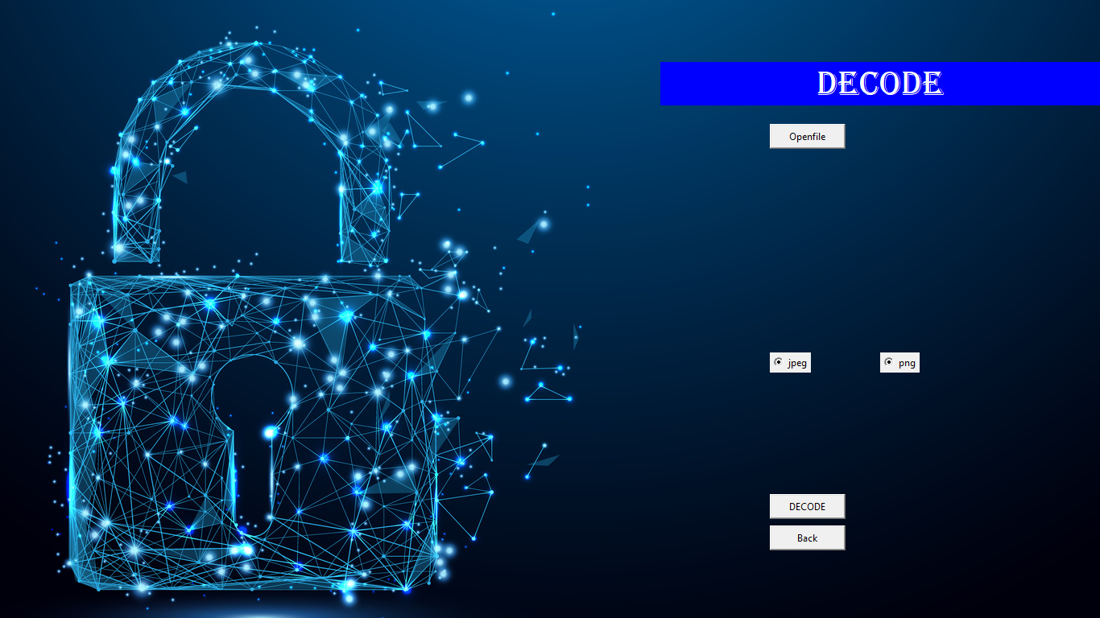

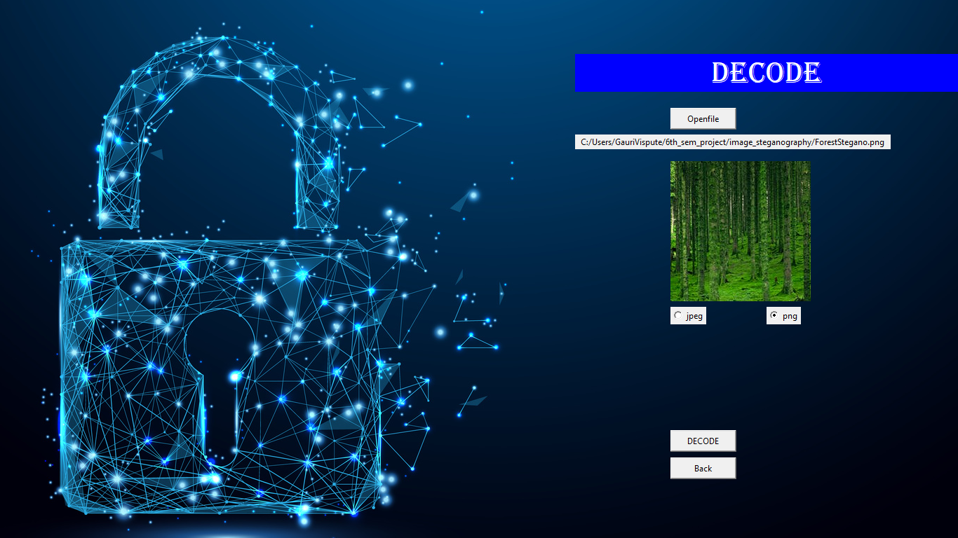

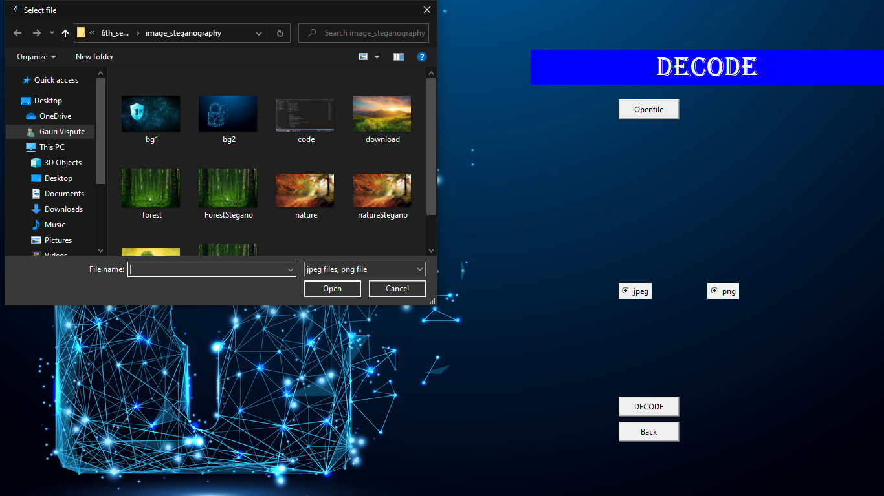

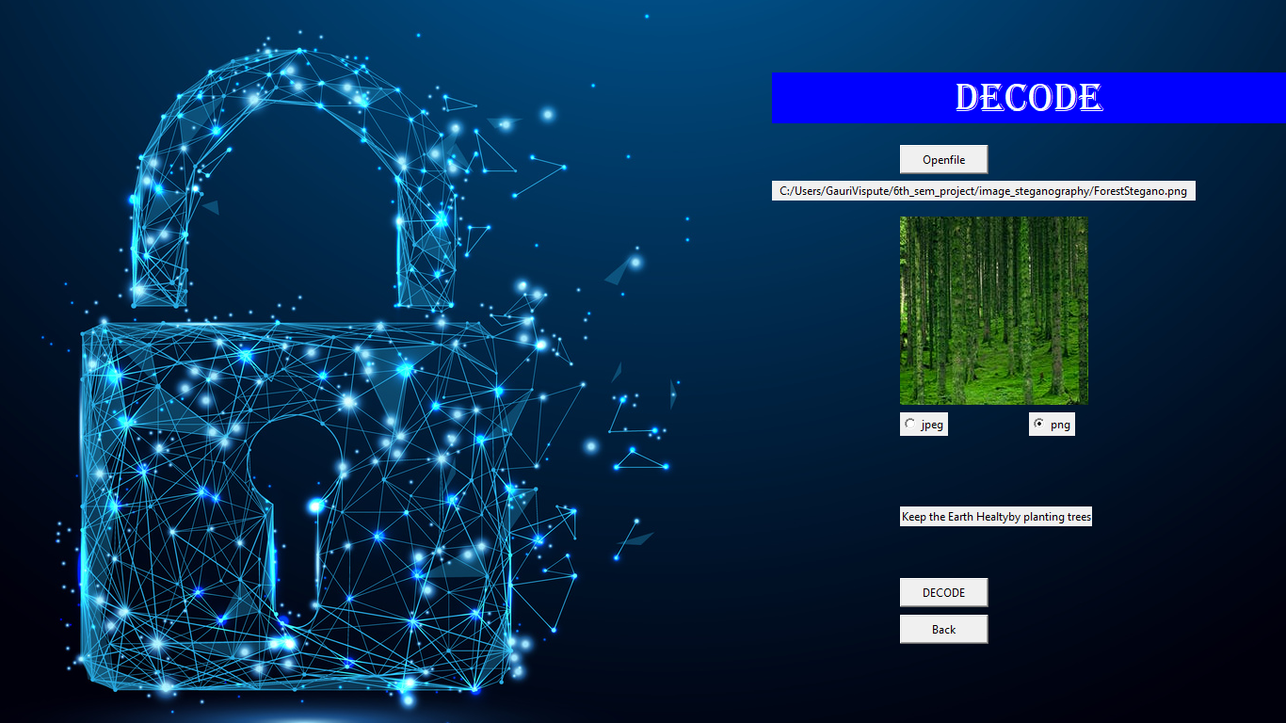5.2 Flow of Modules

1. Secret data: The first step in the data flow is to select the secret data that needs to be hidden within the image.
2. Cover image: The next step is to select a cover image that will be used to hide the secret data.
3. Embedding: The secret data is then embedded within the cover image using a steganographic algorithm. The embedding process involves modifying the least significant bits of the cover image pixels to represent the secret data.
4. Carrier image: Once the secret data has been embedded within the cover image, the resulting image is called the carrier image. The carrier image is then transmitted or stored like any other image.
5. Extraction: To retrieve the secret data from the carrier image, a steganographic algorithm is used to extract the hidden data from the least significant bits of the carrier image pixels.
6. Secret data: The final step in the data flow is to retrieve the secret data from the extracted bits. This can be done by decoding the bits and converting them back to their original form.

**6.Project Access**

Source Code

<https://github.com/ashishyadav2/HexaSEM.git>

Our project is available on the internet and can be accessed anywhere in the world. The source code can also be publicly viewed by the users.

**7.Result**

From a proper analysis of positive points and constraints on the component, it can be safely concluded that the product is a highly efficient GUI based component. This application is working properly and meeting to all user requirements.

**8.Bibliography**

1. <https://ieeexplore.ieee.org/document/9335027>

Image Steganography – A review of recent advances

1. <https://www.geeksforgeeks.org/image-steganography-in-cryptography/>

Reference from Geeks for Geeks

1. <https://www.researchgate.net/publication/314116270_Image_Steganography>

HOD: Prof. Rahul Jinturkar

College: Watumull Institute of Electronics Engineering and Computer Technology, Ulhasnagar

**Acknowledgement**

We have great pleasure in presenting the mini project report on **Image Steganography**. We take this opportunity to express our sincere thanks towards our guide **Professor Nilesh Mehta** Department of Computer Engineering, WIEECT for providing the technical guidelines and suggestions regarding line of work. We would like to express our gratitude towards his constant encouragement, support and guidance through the development of project.

We thank **Prof. Rahul Jinturkar** Head of Department, Computer Engineering, WIEECT for his encouragement during progress meeting and providing guidelines to write this report.

We also thank the entire staff of WIEECT for their invaluable help rendered during the course of this work. We wish to express our deep gratitude towards all our colleagues of WIEECT for their encouragement.

**Student Name1: Ashish Yadav**

**Student Name2: Srishti Shrivastava**

**Student Name3: Gauri Vispute**

**Student Name4: Vivek Tiwari**